INTERNET & PHONE SERVICE INSTALLATION FAQ
If you want to have high-speed internet and/or phone service through the WiredWest/New Salem network, a fiber connection needs to be run into your home from the street. In order to assure this, it is important to sign up BEFORE OCTOBER 31st.
To bring the fiber optic cable from the curb into your home there are two parts to the installation process.
OUTSIDE INSTALLATION – Bringing the fiber optic cable from the curb to the outside of your home.
We are still determining how much of the cost we will be able to cover to bring the fiber optic cable from the curb to the outside of your home in the most direct path and/or lowest cost option available. Our hope is to cover as much of this cost as possible. If you want a customized installation you will pay the difference between the “lowest cost” option and the option you choose.
INSIDE INSTALLATION:
Our hope is to cover all of the cost to bring the fiber optic cable from the outside of your home to the inside of your home in the most direct path and/or lowest cost option available. This will be dependent on our contractor’s final contracted rates as well as the results of our Special Town Meeting vote on September 16. If you want a customized installation you will pay the difference between the “lowest cost” option and the option you choose.
PREP FOR INSIDE INSTALLATION:
Electrical outlets: There MUST be an electrical outlet within 6 ft of where your router (usually centrally located in main part of the house) and ONT (usually located in the basement where the utilities enter your house) will be located. (ONT = Optical Network Terminal, a necessary component to run your home network). It is the homeowner’s responsibility to be sure these outlets are already installed prior to the home fiber installation.
Router location: While the technician will be willing to help you find a good central location for your router, it is good to give some thought to this in advance, especially if you want to locate it further than 50ft from where the ONT will be installed (which will result in costs that you will have to absorb) or if you want it in a location that does not yet have an electrical outlet within 6ft (which will require you to arrange for an electrician to install an outlet in the area you wish to place your router).
STANDARD INSIDE INSTALLATION – Bringing the fiber optic cable inside your home and setting up the electronics and wiring necessary to provide a WiFi (wireless) signal throughout your home. This will include the installation of a free router* provided for your use by Whip City Fiber (our Internet Service Provider). While you can use your own router if you prefer, this router has been chosen by WCF to allow you to make use of the new high-speed service that you will receive. It will also allow their technicians to do some remote troubleshooting, should issues arise.
*Please note that the router and phone equipment are the property of Whip City Fiber (WCF). There is no rental fee however, if service is discontinued, the equipment must be returned. You will be able to return your router and phone equipment (if applicable) to the Town Coordinator at the Stowell Building (Mon & Wed, 8:30am – 4 p.m.). Please call (978) 544-6437 in advance to be sure the office is open. We will arrange for it to be returned to WCF.
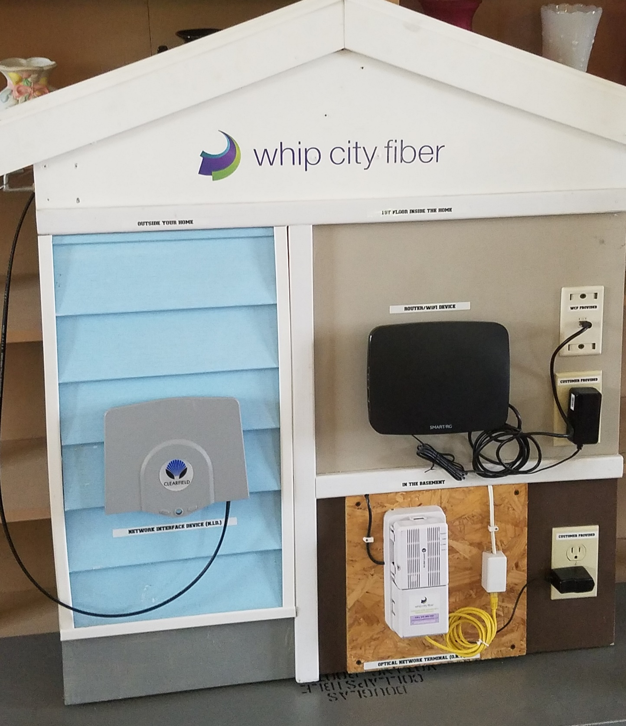
Installation Components:
The above display shows the components that will be installed on and in your house for the network connection. There is a full-size model of this display in the New Salem Library; feel free to come take a look during library hours.

On the outside of the house (blue shingles on the left of the display), the technicians will install the Network Interfact Device (NID). They will then run fiber from this component into your house near where your other utilities enter the premises. On a wall inside the house, close to where the fiber was brought in (usually in the basement), they will install an Optical Network Terminal (ONT) which needs to be within 6 feet of a functioning electrical outlet. It is the responsibility of the owner to be sure that there is an outlet available in this location. The techs will run a CAT6 line (up to 50’) up through the wall to a central location on the first floor where they will install a CAT6 outlet and the router. It also will be the responsibility of the homeowner to be sure there is an existing electrical outlet located within 6 feet of where they want the router installed.
OTHER OPTIONAL UPGRADES:
Landline Phone service includes transferring your current landline phone number and connecting your home wiring. If you just want your phone number transferred to your broadband connection (but no wiring installed) there is no charge.
If you wish to retain your current landline phone number it is very important not to discontinue your landline service with your current provider until you are notified by Whip City Fiber that your number has been successfully ported to your new service.
Please note that if you wish to have your landline phones available in multiple locations in your home, it will be much less expensive for you to purchase a cordless phone system with multiple handsets, available at most online and big-box stores, than to have internal wiring done. With a multiple handset cordless phone you will plug the system base into the router and then place the phone handsets wherever you wish throughout your home.
The product pictured above is being provided as an example of a multi handset cordless phone and is not a specific product recommendation on our part.
Special installation situations: Examples of this include if you need your router run more than 50ft. into your home, need to run the ethernet CAT6 cable through any interior walls or go through or around architectural barriers. Any additional work beyond a standard installation will result in charges that will be your responsibility.
Additional considerations:
In order to keep your router and phone service (as well as your cell phone service over WiFi) active when the power goes out we are recommending a battery backup unit. Home generators can also be used for this purpose however, a battery back-up will provide a handy short-term solution for those more frequent short-term outages. The backup batteries will not be provided as part of the installation process but can be purchased at online stores or big-box stores.
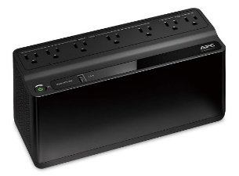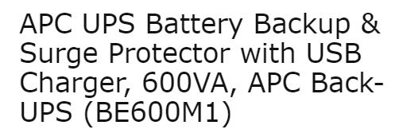
The product pictured and described above is being provided as an example of a battery back-up and is not a specific product recommendation on our part.

THE INSTALLATION PROCESS
INSTALLATION: The installer will contact you and schedule an installation appointment at your convenience.
Installations typically take 2-3 hours. An adult who can make decisions about the installation and authorize any work that will result in additional cost to the homeowner must be present for the installation.
The fiber optic cable will be brought from the curb to your home and will enter your home through a small box mounted on your home near where your existing utilities are located. The technician will then set up the interior electronics.
As soon as the technician is finished, you will have broadband in your home!
SPECIAL CASES: If your current utilities come into your home underground, you’ll have two or more home visits. The installer will first contact you to make an appointment for an installation consult. They will visit your home check existing conduit and/or stake out the proposed dig route to install new conduit. Your home then may or may not require a visit by the New Salem conservation commission. Homes requiring this type of visit will be contacted individually. There will be a DigSafe conducted (to mark the precise location of existing utilities under the ground) that will not require your presence. Once DigSafe permitting is done, the installers will notify you of the day they'll put the conduit in the ground (you don't have to be home for this). Finally, at a later time, once your area is ready for in-home installations, they'll make a second appointment with you and return to install the service inside your home (which will require your presence as noted above).
What if I’m a renter?
Please contact your landlord who can initiate the installation sign-up process. Because the Outside and Inside installation involves work on the property and changes to the wiring, it can only be approved by the property owner.

