Broadband Update August 2019
Things are now moving very quickly with the Broadband project. We will have many important updates coming over the next few weeks but for today we, finally, provide an answer to one of the biggest questions on everyone’s mind…
Here are the prices for the New Salem MLP state-of-the-art Internet service.
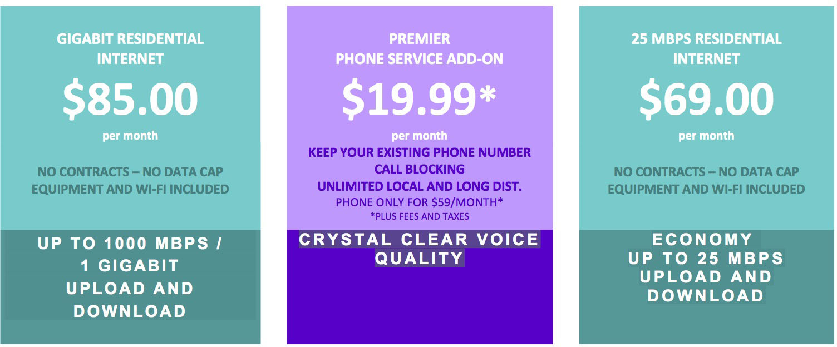
With our Gigabit service, you will be able to stream high-def TV and movies, while doing online homework, while sharing high-resolution photos and video chatting with family, while paying your bills online… well, you get the idea.
Please note: These prices are dependent on at least 75% of the homes in New Salem signing up for service.

