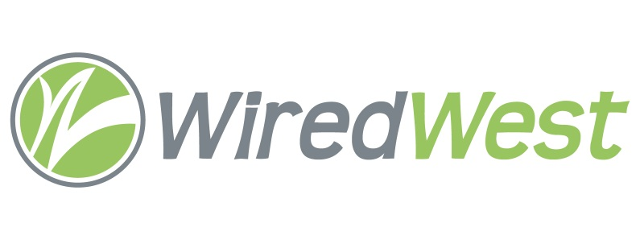
Town
Logo
here
Our town is a charter member of the WiredWest Cooperative. WiredWest is a municipal coop of 40 towns that are working together to build a fiber-optic network to offer ultra-high-speed internet, telephone and high definition video at reasonable rates to residents and businesses.
The WiredWest network is extremely important to the future of our town. It will create local jobs, improve education and healthcare, and support our regional economy. Even if you have DSL, wireless or cable from a private company, switching to WiredWest has enormous benefits for you personally, and for our community, including:
- Far superior service – There is no other delivery system for telecommunications that provides service as quickly, reliably and affordably as fiber-optic. It is only technology that will support our data needs for decades into the future, and give you state-of-the-art service today.

- Keeps revenues here – Today your payments for phone, internet and television service go to out-of-state companies and their shareholders. For just the WiredWest towns, that’s over $50 million per year. Imagine the effect on our local economy if that money stayed here?

- Ensures all Residents and Businesses have access to high-speed internet – Many of our residents are cut off from the modern digital world through no fault of their own. They struggle with dial-up or satellite, which prevents working from home or operating home businesses. It penalizes our students from doing homework and accessing online education tools. It drives young families, professionals and college graduates from our towns. And it makes homes almost unsellable. Even if you’re satisfied with your current internet service, doesn’t it make better sense to support a network that provides service to all your neighbors?

Although the WiredWest network is still in the planning stage, you can do something important today to make sure it comes to fruition in our town. Complete a Support Card to show your interest in service with WiredWest, either at www.wiredwest.net, or pick up a card at [[locations where available]]. We urge you to show support for this vital initiative.

For more information, please visit www.wiredwest.net or contact the [[town name]] WiredWest Delegate, [[delegate name]] at [[contact info]].

